Background:
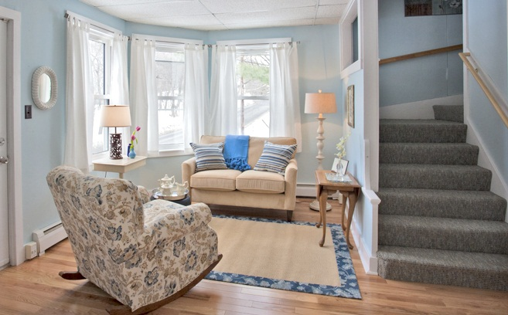
- Founded in 1995 as community coalition to raise awareness of elder abuse in Maine.
- Formed as nonprofit in 2003.
- Received funding from US DOJ in 2009 to provide transitional housing for older victims of domestic violence, sexual assault, stalking.
- Housed first resident in 2011.
- To date, have brought 1.2 million to state to provide services for older victims of abuse.
- One of very few housing programs for older victims of abuse in the country.
- Partners: Safe Voices, Area Agencies on Aging, City of Portland, Maine Council on Elder Abuse Prevention

Need for Program:
- Older victims need a specific set of support services not traditionally available by aging organizations or domestic violence agencies.
- Traditional shelters do not meet the needs of older people; they will not go there.

Program Description:
Through our Martha’s Cottage program, we have three confidential homes in Portland, Lewiston/Auburn and the Southern Midcoast areas of Maine. We provide transitional housing and supportive services to women feeling abuse and help them transition to safe housing.
Average age: 65 years
Youngest: 56 years
Oldest: 77 years old

We have housed over 30 people, none of whom have returned to their previous situation.

We have also provided services to over 250 women and men who choose not to come to our housing. We offer safety planning, informal support and counseling and referral services to help them make choices that help them find safety from abuse.

Clients have come from: Penobscot, Oxford, Androscoggin, York, Cumberland, Washington, Franklin and Lincoln Counties.

Highlights from 2016:
- Opened Lewiston/Auburn. Negotiated donation of free apartment in Southern Midcoast.
- Featured in Downeast Magazine, October 2016. Featured on Maine Point Radio and Times Record.
- Featured speaker at Maine Women’s Fund Annual Luncheon. Invited presenter to first-ever roundtable of housing, aging and domestic violence federal department administrators.
- Secured VOCA funds from the State of Maine.
- Invited to assist Senator to plan Special Senate Hearing on the intersection of aging and domestic violence.
- Hired our first Executive Director since our founding as a 501c3 in 2003.
- Conducted a State of Maine landscape assessment to understand the status of the field of elder abuse in Maine.
- Adopted a Critical Time Intervention model; first evidenced-based programming to be used in our work.

The Voice of a Victim: “I still can't get over what a miracle Martha's Cottage was for me. I know in my soul he would have killed me had I not left when I did. He had talked of killing me before but this time he was more quiet, more resigned to it as if it were inevitable. I just knew it was going to be the end for me and I had to get out.
You told me to just take each day as it came and promised that I’d feel more comfortable in that safe place soon. And I did. I have changed so much since then and have a completely different life. One that I never thought would be possible for me. I thought I’d just keep growing older and then die.
Now I spend time with my family, my brother and his wife, my nieces and nephews and it’s such a joy. I am making up for lost time because I was never allowed to see them before. I take my time grocery shopping knowing there won’t be a price to pay. Sometimes I just want to pinch myself because life is this good. “

